

**SAVEETHA SCHOOL OF ENGINEERING**

**SIMATS, CHENNAI-602105**

**CSA0554 - Database Management Systems for Procedural Languages**

**ASSIGNMENT**

**Traffic Flow Management System (TFMS)**

**Done By:**

**- U.VISHNU**

**192321027**

**Scenario:**

You are tasked with designing an Entity-Relationship (ER) diagram for a Traffic Flow Management System (TFMS) used in a city to optimize traffic routes, manage intersections, and control traffic signals. The TFMS aims to enhance transportation efficiency by utilizing real-time data from sensors and historical traffic patterns.

The city administration has decided to implement a TFMS to address growing traffic congestion issues. The system will integrate real-time data from traffic sensors, cameras, and historical traffic patterns to provide intelligent traffic management solutions. Key functionalities include:

1. **Road Network Management**:
   * **Roads**: The city has a network of roads, each identified by a unique RoadID. Roads have attributes such as RoadName, Length (in meters), and SpeedLimit (in km/h).
2. **Intersection Control**:
   * **Intersections**: These are key points where roads meet and are crucial for traffic management. Each intersection is uniquely identified by IntersectionID and has attributes like IntersectionName and geographic Coordinates (Latitude, Longitude).
3. **Traffic Signal Management**:
   * **Traffic Signals**: Installed at intersections to regulate traffic flow. Each signal is identified by SignalID and has attributes such as SignalStatus (Green, Yellow, Red) indicating current state and Timer (countdown to next change).
4. **Real-Time Data Integration**:
   * **Traffic Data**: Real-time data collected from sensors includes TrafficDataID, Timestamp, Speed (average speed on the road), and CongestionLevel (degree of traffic congestion).
5. **Functionality Requirements**:
   * **Route Optimization**: Algorithms will be implemented to suggest optimal routes based on current traffic conditions.
   * **Traffic Signal Control**: Adaptive control algorithms will adjust signal timings dynamically based on real-time traffic flow and congestion data.
   * **Historical Analysis**: The system will store historical traffic data for analysis and planning future improvements.

**ER Diagram Design Requirements**

1. **Entities and Attributes**:
   * Clearly define entities (Roads, Intersections, Traffic Signals, Traffic Data) and their attributes based on the scenario provided.
   * Include primary keys (PK) and foreign keys (FK) where necessary to establish relationships between entities.
2. **Relationships**:
   * Illustrate relationships between entities (e.g., Roads connecting to Intersections, Intersections hosting Traffic Signals).
   * Specify cardinality (one-to-one, one-to-many, many-to-many) and optionality constraints (mandatory vs. optional relationships).
3. **Normalization Considerations**:
   * Discuss how you would ensure the ER diagram adheres to normalization principles (1NF, 2NF, 3NF) to minimize redundancy and improve data integrity.

**Task 1: Entity Identification and Attributes**

1. **Roads**

* RoadID (PK)
* RoadName
* Length (meters)
* SpeedLimit (km/h)

1. **Intersections**

* IntersectionID (PK)
* IntersectionName
* Latitude
* Longitude

1. **Traffic Signals**

* SignalID (PK)
* IntersectionID (FK)
* SignalStatus (Green, Yellow, Red)
* Timer (seconds)

1. **Traffic Data**

* TrafficDataID (PK)
* RoadID (FK)
* Timestamp
* Speed (km/h)
* CongestionLevel (scale)

**Task 2: Relationship Modeling**

1. **Roads to Intersections**

* Each road can connect to multiple intersections.
* Each intersection can connect to multiple roads.
* **Relationship**: Many-to-Many
* **Optionality**: Mandatory for Intersections, optional for Roads

1. **Intersections to Traffic Signals**

* Each intersection can host multiple traffic signals.
* Each traffic signal is associated with one intersection.
* **Relationship**: One-to-Many
* **Optionality**: Mandatory for Traffic Signals, optional for Intersections

1. **Roads to Traffic Data**

* Each road has multiple traffic data entries.
* Each traffic data entry is associated with one road.
* **Relationship**: One-to-Many
* **Optionality**: Mandatory for Traffic Data, optional for Roads

**Task 3: ER Diagram Design**

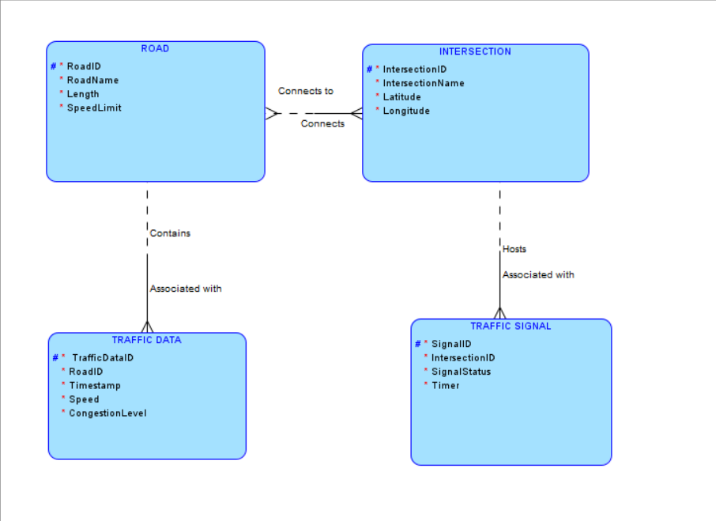

**Task 4: Justification and Normalization**

**Justification:**

* **Scalability**: The design allows for easy addition of new roads, intersections, traffic signals, and traffic data entries.
* **Real-Time Data Processing**: Entities and relationships are structured to facilitate quick updates and retrievals, essential for real-time traffic management.
* **Efficient Traffic Management**: Relationships between roads, intersections, and traffic signals enable the system to optimize routes and manage traffic signals based on real-time data.

**Normalization:**

* **1NF (First Normal Form)**: Ensures that each table has a primary key and that all attributes contain atomic values.
* **2NF (Second Normal Form)**: Ensures that all non-key attributes are fully dependent on the primary key. For instance, all traffic signal attributes are fully dependent on SignalID.
* **3NF (Third Normal Form)**: Ensures that there are no transitive dependencies. Each non-key attribute is dependent only on the primary key, and not on any other non-key attribute.